4.2 Hands On Exploration: Understanding Circuits (PhetSim)

(Individual Assignment: Remote Lab)

This lab uses the Circuit Construction Kit: DC – Virtual Lab simulation from PhET Interactive Simulations at University of Colorado Boulder, under the CC-BY 4.0 license.
https://phet.colorado.edu/sims/html/circuit-construction-kit-dc-virtual-lab/latest/circuit-construction-kit-dc-virtual-lab_en.html

Learning Goals: Students will be able to
- Discuss basic electricity relationships
- Build circuits from schematic drawings
- Use an ammeter and voltmeter to take readings in circuits.
- Provide reasoning to explain the measurements and relationships in circuits.

I. Observing voltage relationships
For this lab, you will use a voltmeter. The function of the voltmeter is to measure the electric potential different (voltage) between two points in an electric circuit. In this case you will use batteries to measure their voltages.
Open the Circuit Construction Kit simulation (CCK). Drag out three batteries and the voltmeter.
- Measure the voltage of two batteries by placing the voltmeter’s input terminal on each side of the battery (as shown on the picture below). Write your findings on the table below.
- Change the voltage of the third battery by tapping on the battery (10 V).
- Place battery 1 and 2 end to end to measure the combined voltage. Write the value on the table below.
- Place battery 1, 2 and 3 to end to measure the combined voltage. Write the value on the table below.
- Take a picture (or use the snipping tool) of the three batteries and the voltmeter showing the combined voltages and include it in the box below.
- Based on the measured voltages, what is the voltage of each battery? Hint: they all measure the same voltage.
Battery | Voltage (V)
1 | 9V
2 | 9V
3 | 10 V
1 + 2 | 18
1 + 2 + 3 | 28

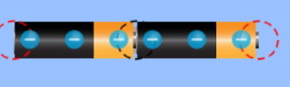  1 + 2  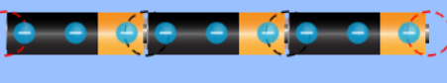  1 + 2 + 3 | 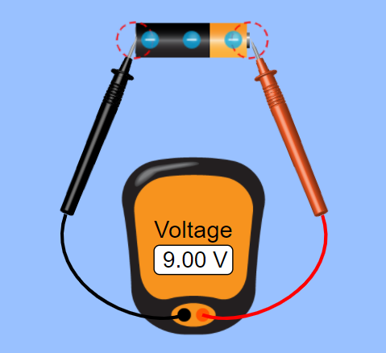  Voltmeter

- Describe the relationship between the number of batteries and the voltage.
As the number of batteries are increased the voltage increases with increase in batteries.

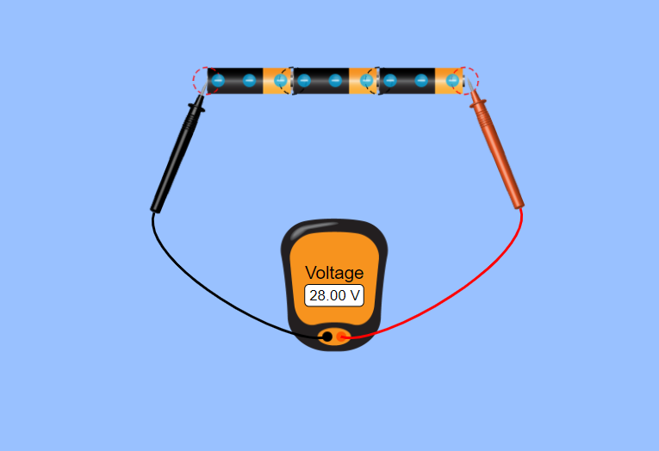

II. Circuit without Load
Use the CCK simulation to build a circuit with wires, battery, ammeter and a switch. The function of the ammeter is to measure the current in a circuit. In a real lab, I will not ask you to do this experiment. This lab will show you how dangerous is to connect wires to battery without a load. Before you start, measure the voltage of the battery that you will use, build a circuit as shown below, keeping the switch off. Close the switch and take a picture or snip it showing the amperes. Once you have taken the picture (or snipped) close the switch. Enter the information and the picture below.
The ammeter shows the current

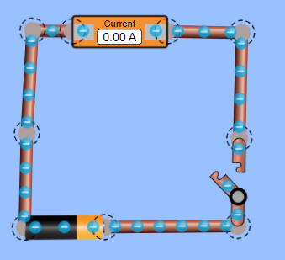

- What is the voltage and the current.

Voltage: 9 V Current: 60390.16 A

- Explain what happens after you close the switch. Enter the picture or use the snipping tool. Don’t burn the computer!

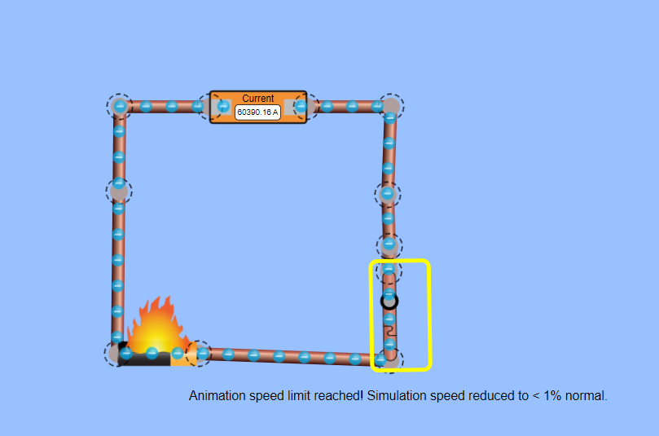

III. Investigating the voltage of series circuits
# of bulbs | Battery  Voltage  ( V ) | Light  voltage (v) | Current (A) | Brightness of bulbs
Example (picture) | 9.0 | 4.5, 4.5 | 0.45, 0.45, 0.45 | Dimmer (compared to one lightbulb)
1 | 9 | 9 | 0.90 | Bright
2 | 9 | 4.5 4.5 | 0.45, 0.45,0.45 | Dimmer (compared to one lightbulb)
3 | 9 | 3 | 0.3,0.3,0.3 | Dimmer (compared to two lightbulb)
Use CCK to build the circuits below with a battery at about 12 volts, lightbulbs, voltmeter and ammeter. For this experiment, you are required to create three circuits, with one light bulb, two light bulbs and three light bulbs. Click on Values to see the value of the battery. See the picture below of a circuit with two lightbulbs. For each circuit, record the battery voltage, current and bulb brightness with descriptive language (dim, dimmer or bright, brighter, brightest or the same brightness). Place the ammeter as it is included in the picture and measure the voltage of each lightbulb. You are to take a picture (or use the snipping tools) of the circuit for two and three light bulbs and upload them below.

Figure 1 Figure 2 Figure 3

- Summarize the relationships you observed and explain what you think is happening.

When the bulbs are connected in series, the voltage and current supplied by the battery is
divided equally between the bulbs.

- For the three lightbulbs circuit, brake the circuit and explain what happens to the other two light bulbs.

The other two bulbs go of as the path of current is disconnected, and therefore no current reaches to the
Other bulbs

- Increase the voltage of the battery of the two lightbulbs and compare it with the previous circuit.

The bulbs light brighter with increased voltage that the previous battery voltage.

Example  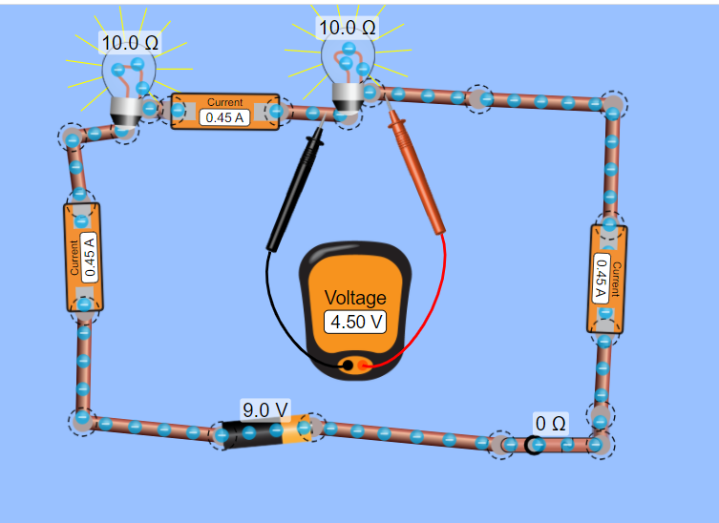 | Include your picture with 2 lightbulbs  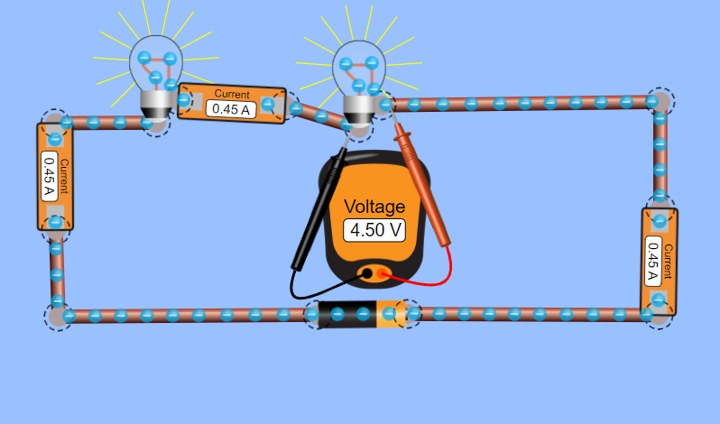 | 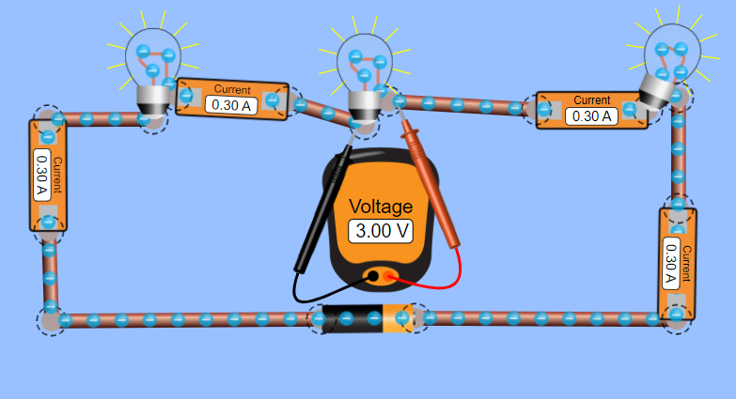

IV. Investigating the voltage in parallel circuits
Redo Part III but use figures 4-6 for the circuits. Make a new table and answer the questions.

Figure 4 Figure 5 Figure 6

# of bulbs | Battery  Voltage  ( V ) | Light  voltage (v) | Current (A) | Brightness of bulbs
Example  (picture) | 9.0 | 9.0, 9.0 | 1.8, 0.9, 0.9, 1.8 | Same brightness as one light bulb
1 | 9 | 9.0,9.0 | 0.90 | same
2 | 9 | 9.0,9.0,9.0 | 0.90,0.90,  0.90 | Same
3 | 9 | 9.0,9.0,9.0 | 0.90,0.90 | Same

- Summarize the relationships you observed and explain what you think is happening.

The way the bulbs are connected a is in such a way that the battery voltages is constant, current is divided equally between the bulbs.

- Test to see if changing the battery voltage causes you to modify any of your conclusions. Explain what you measured and any conclusions you draw from your tests.

Changing the batteries voltage increases the bulbs voltage and therefore increasing the bulbs brightness.

- What happens when you take a wire out of a circuit for the three lightbulbs? Explain what you think is happening

The other bulbs continue to light even after the wire is cut, this is because its only the current pathway of the bulb
That is cut but the rest of the circuit is complete.

Example  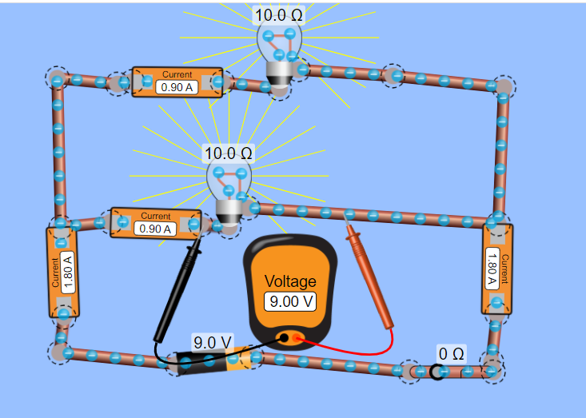 | Include your picture with 2 lightbulbs  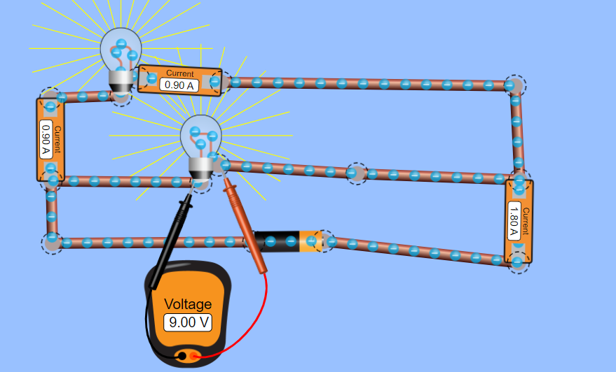 | Include your picture with 3 lightbulbs  